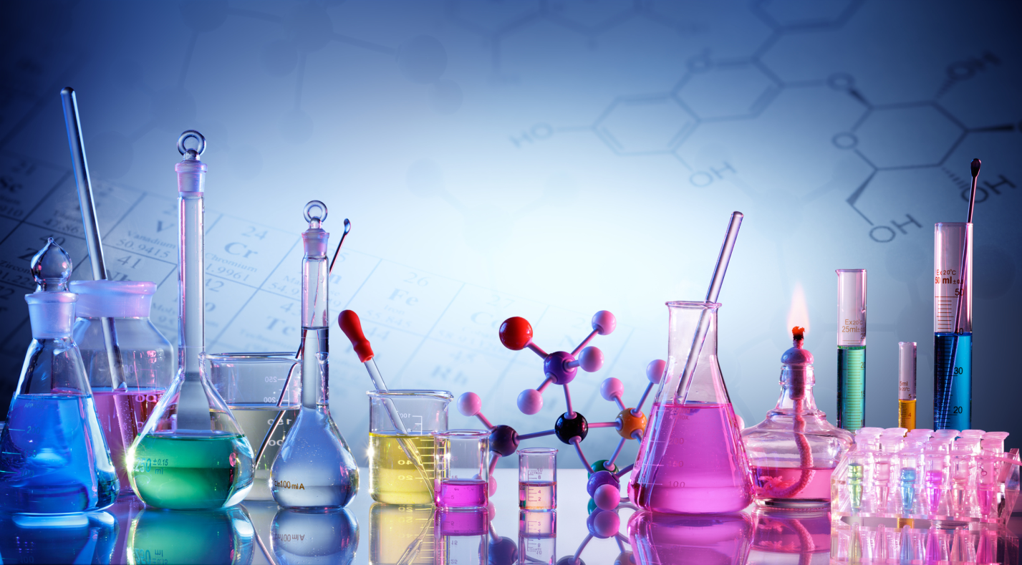


Virtual University of Pakistan

Laboratory Manual: Analytical Chemistry CHE301
CONTENTS
S. NO. | Practical | P. No.
1 | Introduction to Analytical Chemistry | 3
2 | Work Safety Instructions For Persons Working In Chemical Laboratory | 6
3 | Laboratory Technique, Materials And Fundamental Operations | 9
4 | Sampling and Analysis Methods | 13
5 | Calculations Used in Analytical Chemistry | 17
6 | Basic Tools of Analytical Chemistry | 22
7 | Separation of biomolecules by Paper Chromatography | 27
8 | Separation of biomolecules by Column Chromatography | 29
9 | Separation of biomolecules by Thin Layer Chromatography | 33
10 | Determination of molecular weight of proteins by gel filtration | 35
11 | Estimation of sugar by UV/Visible spectrophotometer. | 39
12 | Determination of proteins by UV/Visible spectrophotometer. | 41
13 | Analysis of electrolytes by UV/Visible spectrophotometer. | 44
14 | Determination of sodium content in blood serum by flame photometer. | 46
15 | Determination of potassium content in blood serum by flame photometer. | 49
16 | Mineral analysis of plant tissues using atomic absorption spectrophotometer | 52

Practical No: 1 Introduction to Analytical Chemistry

Analytical chemistry is a science field evolving and adapting methods, devices and strategy for obtaining information about chemical composition, structure and energy state of substances. Goals of analytical chemistry: to detect chemical elements, which compose particular substance?
Qualitative analysis to determine the ratios of different elements in investigative substance
Quantitative analysis various substances differ from each other by composition, structure, physical and chemical properties. Most of properties can be used to learn about qualities, which distinguish substance from others.
These qualities are analytical signals
Methods of analysis are based on obtaining analysis signals and measurement of intensity of signals. According to action, which gives analytic signal, methods of analysis are divided into physical and chemical instrumental methods. They are employed in both in qualitative and quantitative analysis.
Chemical methods of analysis methods based on chemical interaction of atoms, molecules and ions. These methods are employed to detect characterize chemical properties of element or ion. Methods of chemical analysis can be divided according the type of chemical reaction, rate of chemical reaction and advisability (gravimetry, titrimetry, gas analysis, kinetic methods of analysis).
Physical methods are based on different parameters of substance radioactivity, electromagnetic properties, and radiation.
Also there are:
Biological methods based on use of biologically active substances and biological systems.
Biochemical method when substances of biological origin are investigated with chemical methods.
Analysis of chemical composition of substance proceeds by following steps:
- Choosing a sample; preparation of sample for analysis
- Extraction of component to investigate, purification; choosing method and scheme of analysis
- Disruption or solving of sample
- Separation and concentration
- Measurement of physical properties of sample, chemical reagent or product of chemical reaction
- Calculation of analysis data
- Estimation of results reliability.
Terminologies:
The sample is a material that we wish to analyze and also has a statistical meaning. The analyte is the substance or element in the sample whose presence or concentration we wish to determine. The matrix is other components of the sample other than the analyte.
The Analytical Process
Every scientist requires an understanding of analytical science so that the data produced fit the purpose. Analytical science can be considered as the science of problem solving. As can be seen in Figure, analytical science is a process rather than an end in itself:
• The technical approach to solving the problem requires the analyst to consider the analytical information, required level of accuracy, the cost, timing, availability of instruments and facilities before selecting the method.
• Knowledge and practical skills start with sampling. Without a representative sample, the results from the time consuming analysis are of little use. This is followed by the sample treatment to produce the analyte into suitable form for detection/measurement by the selected analytical technique. This may involve dissolution, separation of the analyte from the sample matrix or converting the analyte to another form.
• Interpretative skills are essential to determine the significance of the analytical results and their relevance in solving the original problem.
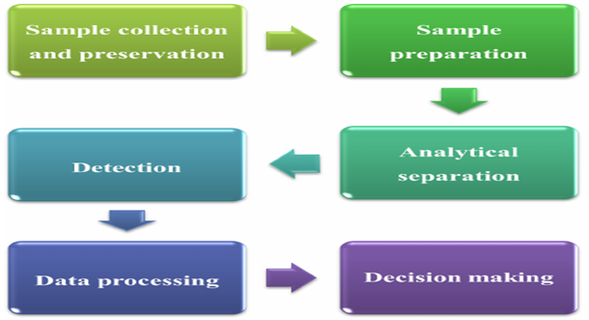
Fig 1.1: Analytical process of sample
Table 1.1: A few commonly used terminologies are given in the Table
Validation | The process of verifying that a procedure yields acceptable results.
QA/QC | Those steps taken to ensure that the work conducted in an analytical
 | Lab is capable of producing acceptable results.
Mean | The average of a set of data
Median | Middle value(s) when a set of data is arranged in ascending or
 | descending order
Range | Difference between the largest and smallest values in a set of data
Std. dev (s) | A statistical measure of average deviation from the mean of a set of
 | data
Error | A measure of bias in a result
Variance | Square of standard deviation (s)
Sampling error | Error occurred during sampling process
Method error | Error due to limitations of the analytical method
Personal error | Error due to analyst & his/her approach
Measurement error | Error due to limitations in the equipment / instrument used
Determinate error | Error that can be traced to the source – above FOUR
Outlier | A datum which is far larger / smaller than the remaining data
Repeatability | The precision for analysis in which the only source of variability is the
 | analysis of replicate samples
Reproducibility | Precision of results of several samples, several analysts or several method
Indeterminate | Sources are not known but affects the scatter around the central value
errors | (mean)
Uncertainty | The range of possible values for a measurement
Confidence | Range of results around a mean value that can be explained by random
intervals | error
Histogram | Profile of frequency as a function of the range of measured values
Normal distribution | Normalized frequency ( probability) of measured values
Degrees of | Number of independent values on which the result is based
freedom
Significance test | A statistical test to determine whether the difference between two
 | Values are significant or not.
Null hypothesis | A statement that the difference between two values can be explained by
 | indeterminate error
SRM / CRM | Material certified with known concentrations of the analytes
Type 1 error | The risk of falsely rejecting null hypothesis
Type 2 error | The risk of falsely retaining the null hypothesis
t-test | For comparing two mean values
F -test | For comparing two variances

Practical No: 2 Work Safety Instructions for Persons Working in Chemical Laboratory

GENERAL PART
- Student must obey established order in the work place, take care of his or her health and of colleagues' health, perform requirements of this instruction.
- Students can't use devices, which have defects and must report lecturer about them.
- Don't use defect sockets, plugs, switches and other defect equipment. Electrical devices must be grounded, if it is required by use rules. Switch off electrical device if current flow outside circuit is noticed.
- Don't connect to one socket several high power devices, if their requirement of current may exceed permeability of installation cables. Remember, voltage up to 36 volts is not dangerous to human.
- Work carefully with laboratory equipment, glassware and devices and start work with them only after learned how to use them. If equipment is broken, report to laboratory worker immediately.
- If gas, water supply, canalization, electricity system defect is noticed, report to laboratory worker. If gas flow is noticed, close gas valve and don't switch on any devices, which can induce flame or sparks.
- When leaving laboratory, check if all electrical and gas devices are switched off and if no water or gas flow is present. Last leaving laboratory person is directly responsible for this requirement.
- Wear lab coat during the practical classes and wear closed toe shoes.
- Wash your hands thoroughly when exiting and entering the lab. Biochemical experiments are very sensitive to contamination & the chemicals can harm you without any symptoms being apparent.
- Keep your desk and apparatus neat and clean. At the end of the laboratory period, clean and put away all apparatus, and wash and dry the desktop.
- Leave any food, beverages outside the lab. Never drink water or eat anything in the laboratory.
- Properly label and store all chemicals.
- Do not smell or taste chemicals
- Do not keep a vessel with the base or acid near your eyes.
- Never use mouth suction for pipetting or starting a siphon
- Do not discard any chemicals down the sink unless instructed to do so.
- Never leave spilled chemicals or water on a desktop or floor. Clean up immediately.
- Read the label carefully before using any chemical.
- Never return unused chemicals to the stock bottles. This may lead to contamination of the entire supply of reagent.
- Be careful not to mix stoppers or caps of reagent bottles.
- Never pour water into conc. acid. Pour the acid slowly into the water with stirring. (In a fume hood).
- Know the properties (i.e., flammability, toxicity, and reactivity) of the chemicals in use. All hazardous chemicals must be handled in the fume hood.
- Consult the teacher before using any unfamiliar equipment.
- Report any injury, no matter how slight, to your instructor
Personal care:
- Work only with clean laboratory robes.
- Wash hands before and after work with warm water and soap, use disinfection and neutralization measures.
- Don't keep food at the work place, eat only in special place.
HANDLING OF REAGENTS AND DEVICES
- All experiments with strong smelling, explosive, dangerous to health or volatile substances are performed in fume hood, with protecting glass lowered.
- When working with strong smelling, dusty, dangerous to health substances not in the fume hood, respiratory mask and safety glasses must be used.
- Flammable substances and heating devices must be handled extremely carefully. Don't heat ether (C2H5-O-C2H5), ethanol (C2H5-OH), petrol (Cs-C9) using opened flame or opened electrical heater. Heat them carefully, on closed electrical cooker or in water bath.
- Use for chemical experiment exact amount of substance, as indicated in laboratory work instruction.
- Avoid contact with chemicals which may cause external or internal injuries. External injuries are caused by skin exposure to caustic/corrosive chemicals (acid/base/reactive salts).
- Use pipettes with holders and avoid mouth pipetting.
- Store acids and bases separately, in well-ventilated areas and away from volatile organic and oxidisable substances.

Practical No: 3 Laboratory Technique, Materials and Fundamental Operations

Students, who work in a chemistry laboratory, must know the purpose, potential use and all features of the laboratory's equipment, devices and tools. The success of laboratory session is determined by accurately, thoroughly performed operations and actions, named in the description of an experiment, as well as acquirement.
While working in the analytical chemistry laboratory it is necessary to learn how to:
- Prepare laboratory glassware, Instruments and filters for work
- How to filter, to heat and to dry materials
- To measure liquid volume or weight with technical and analytical balance
- To assemble chemical equipment
- How to prepare solutions of required concentration
- To calculate the required amount of reagents, the yield of reaction products and the relative error
- To describe accomplished session
- To draw used devices and chart graphs.
Cleaning of laboratory glassware
Before use, all glassware should be thoroughly cleaned to prevent errors caused by contaminants. First of all the glassware is washed with tap water, using small amounts of soap or soda and a brush to scrub the glassware. If the glassware is not truly cleaned, the dirt is eliminated while washing with hydrochloric acid or "cleaning mixture": concentrated sulphuric acid (H2SO4) is poured in 200 ml of saturated potassium dichromic acid (K2Cr2O7) solution mixture reaches 500 ml. The glassware surface is rinsed in such "cleaning mixture" for several minutes, but for ease of use the utensil can be filled with solution or dipped into it and left to stay for longer time.
Finally it should be washed with tap water and rinsed with deionized water, tipping and rolling the glassware. If rinsing a pipette, burette or other glassware with a tip, water needs to be discarded through the tip. The clean glassware should be inverted on a paper towel to dry.
Warming, drying, heating
Spirit lamps, electric and gas burners, water baths, drying and heating ovens, and thermostats are used for warming in the laboratory. Thermal resistant substances are dried in the electric drying ovens (100 - 125 ⁰C), and thermal non-resistant substances – in the vacuum drier or desiccator, which is filled with moisture sorbent. The materials heated at 800 - 1000°C temperature lose all volatile impurities, and sometimes they decompose into the thermal resistant compounds. It is mainly heated in the electric muffle furnace and on the flame of gas burner at times. The heated material is placed in the porcelain, quartz or platinum crucible.
Filtration
The process usually employed to separate an insoluble solid from a liquid is called filtration. After the filtration process, the liquid that passes through the filter paper (filtrate), and/or the solid that remains on the filter paper (precipitate or residue), can both be used. It is used for filtration:
• Filters of filter paper are cut from simple filter paper and first folded in half.
Then paper is folded again in squeeze-box form, but not in perfect quarters: the two folded edges should not quite touch; the second edge should be about 3 mm from the first edge. The filter is cut to a diameter that fits snug to the funnel walls, not reaching edges. The liquid with residues is poured into the funnel through the glass stick insomuch that its height would not reach filter's border 10 mm. If only the filtrate is required for further work, it should be filtrated through the folded filter (speed of filtration is faster);
• Ash less filters are used to perform quantitative analysis. The density of these filters is indicated on a tag of a cover. We can decide about ash less filter's density from strip color of a cover: red - least density, white - medium density, blue - close;
• Glass filters - glass funnels with poured spongy glass plate. The density of filters is marked by four numbers: No. l - least density, No.4 - most density;
• Vacuum filtration - Buchner filter with holey porcelain bottom is used and moistened with water and paper filter is placed on it. Paper filter should freely go in a funnel; its edges shouldn't be turned back. Buchner filter that is prepared for filtration is inserted into Bunsen flask, which is connected with water or mechanical pump in order to make vacuum;
• Warmed filters are used to filter viscous liquid, saturated and oversaturated solutions. Collected residues are thoroughly washed several times with small amount of a solvent (water). Another portion of liquid is poured only then, when an initial is out flowed completely. If liquid over the residues is utterly clean, it can be decanted (poured without roiling liquid) before the filtration. It is possible to wash the residues, which remained after the decantation, on several occasions with a solvent (water) again in order to eliminate impurities.
Measurement
The measurement of liquid volume can be performed using graduated cylinders, volumetric flasks and measuring vessels. Unlike counting, which can be exact, measurements are never exact but are always estimated quantities. Obviously, some instruments make better estimates than others, so more precise liquid volume is measured by calibrated measuring vessels:
• Pipette – vessel, used to suck, to drop and to measure liquid. Mohr pipette measures only one, definite and marked on it volume. Graduated pipettes allow measurement of any volume that would not exceed the volume of pipette's graduated section. Such pipettes commonly are graduated with 0.1 ml scale and allow to measure volume in 0.005 ml precision. Semi micropipettes and micropipettes can be graduated with 0.01 and 0.001 ml scale;
• Automatic micropipette – instrument, used to suck, to drop and to measure liquid.
• Burette - glass tube (generally with 0.1 ml scale), used to drop and to measure liquid volume. Semi micro burettes and micro burettes can be graduated with 0.01 or 0.001 ml scale;
• Measuring flasks – are used to measure various volumes and to prepare various concentration solutions.
Volume of liquid, which is colorless and moistens surfaces, is measured looking at the bottom of liquid's meniscus in the measuring vessels. Colorful liquid’s volume, when we can't see the bottom of meniscus, is measured by deducting according to a top of meniscus. Meniscus should be in a level of a person who measures

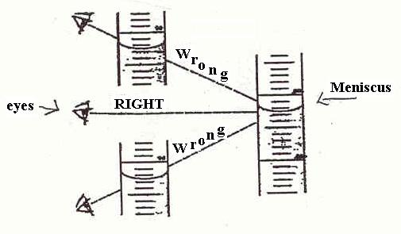
Fig 3.1: Measuring flask view

Practical No: 4 Sampling and Analysis Methods

Sampling and Sample Preparation
The term "sample" in analytical chemistry is applied to a portion of material selected in an appropriate manner, to represent a larger body of material. The result obtained from the samples is merely an estimate of the quantity or concentration of a constituent or property of the bulk material from which this sample is taken. The parent material may be homogeneous or heterogeneous. The use of a sample is always likely to introduce an uncertainty, arising from heterogeneity of the parent material and in extrapolating from the smaller portion to the larger portion called the "sampling error."
Sampling consists of two important steps- the sample collection step (sampling) and sample preparation step. The overall uncertainty is more often limited by problems with sampling or sample preparation than by the analysis of the prepared sample. If samples collected are the wrong size or type, even the best lab analysis of those samples may not be able to correctly represent the analysis of bulk material and thus may not serve the intended purpose.
Sampling Techniques:
Mixing
Mixing is combining of components, particles, or layers into a more homogeneous state.
The mixing may be achieved manually or mechanically by shifting the material with stirrers or pumps or by revolving or shaking the container. The process must not permit segregation of particles of different size or properties. Homogeneity may be considered to have been achieved in a practical sense when the sampling error of the processed portion is negligible compared to the total error of the measurement system.
Reduction of size
Decreasing the size of the laboratory sample or individual particles, or both is achieved by the division of the bulk material. Division of the size of the laboratory sample is generally accomplished manually by coning and quartering or by riffling or mechanically by rotary dividers.
Reduction of particle size may be accomplished by milling or grinding. Simultaneous division and reduction may also be achieved with mills having stream diverters.
Coning and quartering
Coning and quartering is one of the methods for preparing representative sample from the powdered sample by forming a conical heap. The heap is spread out into a circular, flat cake. The cake is divided radially into quarters and two opposite quarters are combined. The other two quarters are discarded. The process is repeated as many times as necessary to obtain the quantity desired for the final use.
Riffling
The separation of a free-flowing sample into (usually) equal parts by means of a mechanical device composed of diverter chutes.
Milling/grinding
In milling and grinding mechanical reduction of the particle size of a sample is achieved by attrition (friction). The required particle size of a sample is related to the size of the test portion and the number of particles required to ensuring homogeneity among test portions. The reduction in particle size may sometimes result in particles of different hardness and density, which produces in-homogeneity during the preparation of the test sample or during the withdrawal of the test portion.
Sample Types
Random sample:
The sample so selected that any portion of the population has an equal chance of being chosen.
Representative sample
A sampling plan that adequately reflects the characteristics of the population. The degree of representativeness of the sample may be limited by cost or convenience.
Selective sample:
A sample that is deliberately chosen by using a sampling plan that screens out materials with certain characteristics and/or selects only material with other relevant characteristics.
Stratified sample:
A sample consisting of portions obtained from identified subparts (strata) of the parent population. Within each stratum, the samples are taken randomly. The objective of taking stratified samples is to obtain a more representative sample than that which might otherwise be obtained by random sampling.
Convenience sample:
A sample chosen on the basis of accessibility, expediency, cost, efficiency, or other reason not directly concerned with sampling parameters.
Duplicate (duplicate) sample:
Multiple (or two) samples taken under comparable conditions. A duplicate sample is a replicate sample consisting of two portions. The umpire sample is often used to settle a dispute and the replicate to estimate sample variability.
Umpire sample/referee sample/reserve sample:
A sample taken, prepared, and stored in an agreed manner for the purpose of settling a dispute, if arises.
Sequential sample:
Units, increments, or samples taken one at a time or in successive predetermined groups, until the cumulative result of their measurements (typically applied to attributes), as assessed against predetermined limits, permits a decision to accept or reject the population or to continue sampling.
Multistage sampling
Samples taken in a series of steps with the sampling portions constituting the sample (units or increments) at each step being selected from a larger or greater number of portions of the previous step, or from a primary or composite sample.
Sample Preparation, storage and handling:
In analytical chemistry, sample preparation refers to the ways in which a sample is treated prior to its analysis. Preparation is a crucial step in most of the analytical techniques, because the techniques are often not responsive to the analyte in its in-situ form, or the results are distorted by interfering species. Sample preparation may involve dissolution, reaction with some chemical species, pulverizing, treatment with a chelating agent (e.g. EDTA), masking, filtering, dilution, sub-sampling or many other techniques. Sample preservation, storage, and handling must be established in the work plan prior to sample collection.
Sample preparation, storage and handling should consider the following:
Sample volume:
Samples should be collected using equipment and procedures appropriate to the matrix, the parameters to be analyzed, and the sampling objective. The volume of the sample collected must be sufficient to perform the analysis requested, as well as the quality assurance/quality control requirements
Sample Container:
Containers must be compatible with the sample matrix, clean and labeled appropriately. The exterior of the sample containers must be wiped clean and dry prior to sample packaging. To prevent leakage of aqueous samples during shipping, sample containers should be no more than 90 percent full. If air space would affect sample integrity, fill the sample container completely and place the container in a second container to meet the 90 percent requirement.
Sample Preservation:
When a preservative other than cooling is used, the preservative is generally added after the sample is collected. If necessary, the pH must be adjusted to the appropriate level and checked with pH paper in a manner, which will not contaminate the sample. The laboratory performing the analysis should be contacted to confirm the requirements for sample volumes, container types, and preservation techniques.

Practical No: 5 Calculations Used In Analytical Chemistry

Measurements in Analytical Chemistry
Analytical chemistry is a quantitative science. Whether determining the concentration of a species, evaluating an equilibrium constant, measuring a reaction rate, or drawing a correlation between a compound’s structure and its reactivity, analytical chemists engage in measuring important chemical things.
Units of Measurement
A measurement usually consists of a unit and a number expressing the quantity of that unit. We may express the same physical measurement with different units, which can create confusion. For example, the mass of a sample weighing 1.5 g also may be written as 0.0033 lb or 0.053 oz. To ensure consistency, and to avoid problems, scientists use a common set of fundamental units, several of which are listed in Table. These units are called SI units after the Système International d’Unités.
Table 5.1: SI base unites
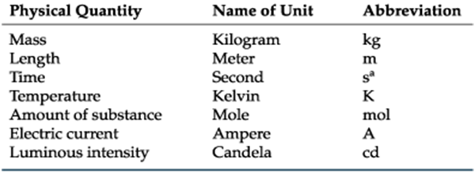

Table 5.2: Here is the table providing a list of some important derived SI units, as well as a few common non-SI units.
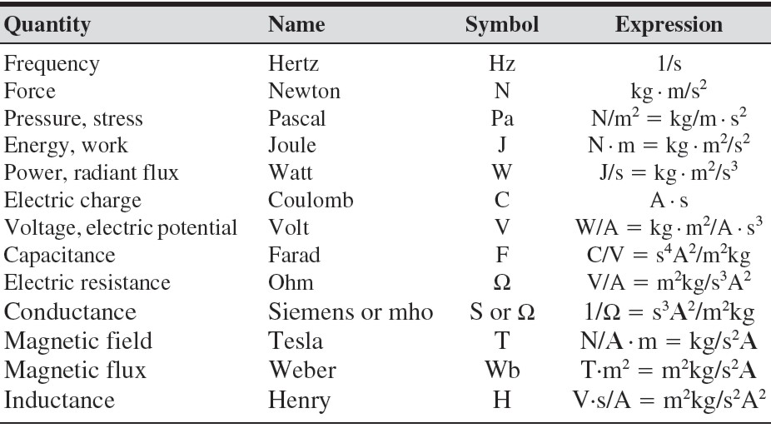
Chemists frequently work with measurements that are very large or very small. A mole contains 602 213 670 000 000 000 000 000 particles and some analytical techniques can detect as little as 0.000 000 000 000 001 g of a compound. For simplicity, we express these measurements using scientific notation; thus, a mole contains 6.022 136 7 × 1023 particles, and the detected mass is 1 × 10–15 g. Sometimes it is preferable to express measurements without the exponential term, replacing it with a prefix (Table). A mass of 1×10–15 g, for example, is the same as 1 fg, or femtogram. Here is the table for some commonly used prefixes.
Table 5.2: View of common SI Prefixes
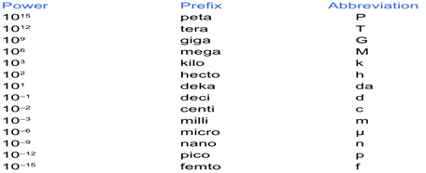

Significant Figures
Significant figures are a reflection of a measurement’s magnitude and uncertainty. The number of significant figures in a measurement is the number of digits known exactly plus one digit whose value is uncertain.
If the mass is 1.2673 g, for example, has five significant figures, four which we know exactly and one, the last, which is uncertain.
Suppose we weigh a second cylinder, using the same balance, obtaining a mass of 0.0990 g. Does this measurement have 3, 4, or 5 significant figures? The zero in the last decimal place is the one uncertain digit and is significant. The other two zero, however, serve to show us the decimal point’s location. Writing the measurement in scientific notation (9.90 × 10–2) clarifies that there are but three significant figures in 0.0990.
Example
How many significant figures are in each of the following measurements, Convert each measurement to its equivalent scientific notation or decimal form.
- 0.0120 mol HCl
- 605.3 mg CaCO3
- 1.043 × 10–4 mol Ag+
- 9.3 × 104 mg NaOH
Solution
- Three significant figures; 1.20 × 10–2 mol HCl.
- Four significant figures; 6.053 × 102 mg CaCO3.
- Four significant figures; 0.000 104 3 mol Ag+.
- Two significant figures; 93 000 mg NaOH.
Significant Figures in Calculations
Significant figures are also important because they guide us when reporting the result of an analysis. In calculating a result, the answer can never be more certain than the least certain measurement in the analysis. Rounding answers to the correct number of significant figures is important.
For addition and subtraction round the answer to the last decimal place that is significant for each measurement in the calculation. The exact sum of 135.621, 97.33, and 21.2163 is 254.1673. Since the last digit that is significant for all three numbers is in the hundredth’s place

135.6 1
97.3
+ 21.2 63
___________
157.1673
______________
To avoid “round-off” errors it is a good idea to retain at least one extra significant figure throughout any calculation. Better yet, invest in a good scientific calculator that allows you to perform lengthy calculations without recording intermediate values. When your calculation is complete, round the answer to the correct number of significant figures using the following simple rules.
- Retain the least significant figure if it and the digits that follow are less than half way to the next higher digit. For example, rounding 12.442 to the nearest tenth gives 12.4 since 0.442 is less than half way between 0.400 and 0.500.
- Increase the least significant figure by 1 if it and the digits that follow are more than half way to the next higher digit. For example, rounding 12.476 to the nearest tenth gives 12.5 since 0.476 is more than half way between 0.400 and 0.500.
- If the least significant figure and the digits that follow are exactly halfway to the next higher digit, then round the least significant figure to the nearest even number. For example, rounding 12.450 to the nearest tenth gives 12.4, while rounding 12.550 to the nearest tenth gives 12.6. Rounding in this manner ensures that we round up as often as we round down.
Concentration and its units
Concentration means the relative amounts of the components of a solution. It tells the ratio of the quantity of one component to the quantity of the other or to the total quantity of solution. It has many units. Some common units are discussed below.
Mass Percentage
The ratio of the mass of the solute to the mass of the solution multiplied by 100 is called mass percentage.
Mass Percentage of a solute = Mass of the solute x 100
Mass of solution
For liquid-liquid solutions, it is sometimes more convenient to express the concentration in the units of percentage by volume:
Volume Percentage of a liquid = Volume of the liquid x 100
Total volume
Parts per Million (ppm)
This is used to express very dilute concentrations of a substance. One ppm is equal to 1 mg of solute dissolved per litre of solvent or 1 mg of solute dissolved per kg of solvent.
Molarity (M)
Molarity or the molar concentration is the number of moles of solute dissolved per dm3 of solution. (1 dm3 is equal to 1 Liter)
Molarity = Number of moles of solute
Volume of solution in liters
Molality (m)
Molality is the number of moles of solute dissolved per kilogram of solvent.
Molality = Number of moles of solute
Kg of solvent
Normality (N) Normality is the number of equivalents dissolved per liter of solution.
Normality = No. of equivalents
Volume of solution in liters
pH
The pH is defined as follows:
“The pH of a solution is the negative logarithm to the base 10 of the hydrogen ion (or hydronium ion) concentration”.
pH = -log10 [H+]
pH = - log10 [H3O+]
The pH of a neutral solution is 7, the pH of acids is less than 7 while that of bases is higher than 7.

Practical No: 6 Basic Tools of Analytical Chemistry

Equipment for Measuring Mass
An object’s mass is measured using a digital electronic analytical balance. An electromagnet levitates the sample pan above a permanent cylindrical magnet. The amount of light reaching a photo detector indicates the sample pan’s position. Without an object on the balance, the amount of light reaching the detector is the balance’s null point. Placing an object on the balance displaces the sample pan downward by a force equal to the product of the sample’s mass and its acceleration due to gravity.
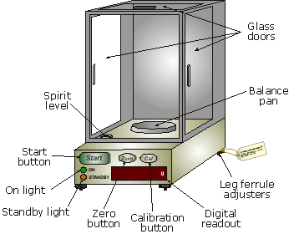
Fig 6.1: View of digital electronic analytical balance
If the sample is not moisture sensitive, a clean and dry container is placed on the balance. The container’s mass is called the tare. Most balances allow you to set the container’s tare to a mass of zero. The sample is transferred to the container, the new mass is measured and the sample’s mass determined by subtracting the tare. Samples that absorb moisture from the air are treated differently. The sample is placed in a covered weighing bottle and their combined mass is determined. A portion of the sample is removed and the weighing bottle and remaining sample are reweighed. The difference between the two masses gives the sample’s mass.
Equipment for Measuring Volume
Analytical chemists use a variety of glassware to measure a liquid’s volume. The choice of what type of glassware to use depends on how accurately we need to know the liquid’s volume and whether we are interested in containing or delivering the liquid.
A graduated cylinder is the simplest device for delivering a known volume of a liquid reagent. The graduated scale allows you to deliver any volume up to the cylinder’s maximum. Typical accuracy is ±1% of the maximum volume. A 100-mL graduated cylinder, for example, is accurate to ±1 mL. A volumetric pipet provides a more accurate method for delivering a known volume of solution. Several different styles of pipets are available.
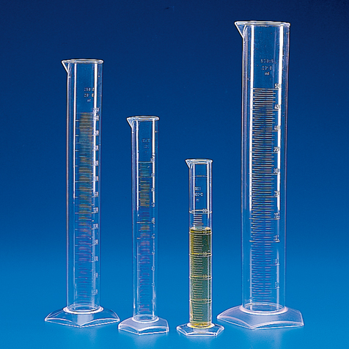
Fig 6.2: Measuring Cylinders
Graduated Cylinders
Transfer pipets provide the most accurate means for delivering a known volume of solution. A transfer pipet delivering less than 100 mL generally is accurate to the hundredth of an mL. Larger transfer pipets are accurate to the tenth of a mL. For example, the 10-mL transfer pipet in Figure will deliver 10.00 mL with an accuracy of ±0.02 mL.
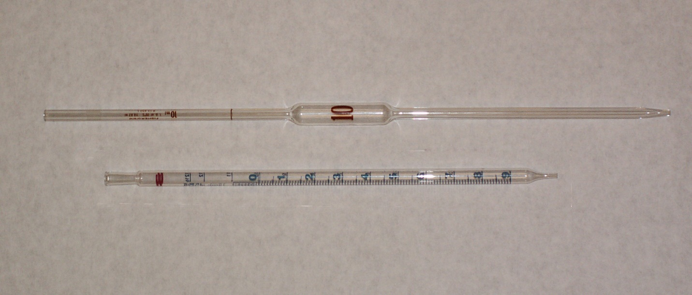
Fig 6.3: Transfer pipets
Delivering microliter volumes of liquids is not possible using transfer or measuring pipets. Digital micropipettes which come in a variety of volume ranges, provide for the routine measurement of microliter volumes.
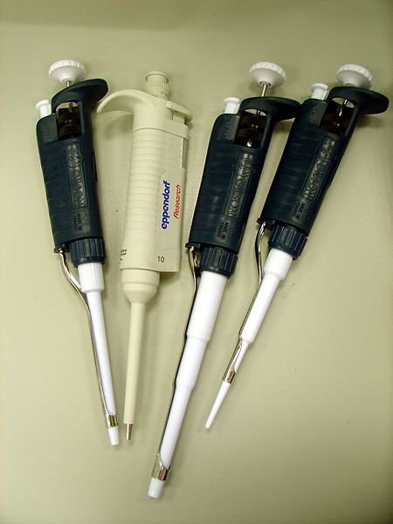
Fig 6.4: View of pipets

A volumetric flask, on the other hand, contains a specific volume of solution.

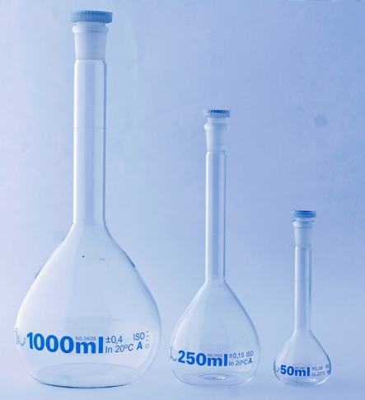
Fig 6.5: A volumetric flask
Equipment for Drying Samples
Many materials need to be dried prior to analysis to remove residual moisture. Depending on the material, heating to a temperature between 110 ºC and 140 ºC is usually sufficient. Other materials need much higher temperatures to initiate thermal decomposition.
Conventional drying ovens provide maximum temperatures of 160 ºC to 325 ºC (depending on the model). Some ovens include the ability to circulate heated air, allowing for a more efficient removal of moisture and shorter drying times. Other ovens provide a tight seal for the door, allowing the oven to be evacuated. In some situations a microwave oven can replace a conventional laboratory oven. Higher temperatures, up to 1700 ºC, require a muffle furnace.
After drying or decomposing a sample, it should be cooled to room temperature in a desiccator to prevent the re-adsorption of moisture. A desiccator (Figure 2.11) is a closed container that isolates the sample from the atmosphere. A drying agent, called a desiccant, is placed in the bottom of the container. Typical desiccants include calcium chloride and silica gel. A perforated plate sits above the desiccant, providing a shelf for storing samples. Some desiccators include a stopcock that allows them to be evacuated.

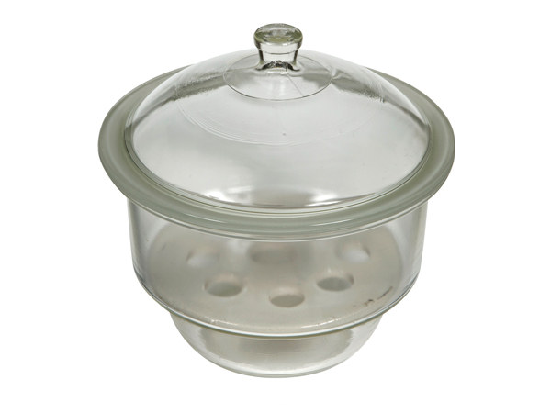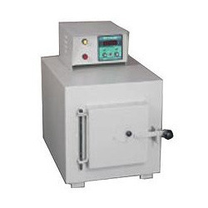
Desiccator Muffle Furnace
Fig 6.5: Equipment for Drying Samples

Practical No: 7 Separation of Biomolecules by Paper Chromatography

Paper chromatography of amino acids
Materials Required: Whatmann filter paper (12x22 cm), Butan-1-ol, Acetic acid, ninhydrin spray (2% solution of ninhydrin in ethanol), Capillary tube, beaker (500 ml), oven.
Chromatography
Chromatography is the separation of sample components based on differential affinity for a mobile versus a stationary phase. The mobile phase is a liquid or a gas that flows over or through the stationary phase, which consists of spherical particles packed into a column. When a mixture of proteins is introduced into the mobile phase and allowed to migrate through the column, separation occurs because proteins that have a greater attraction for the solid phase migrate more slowly than do proteins that are more attracted to the mobile phase.
Several different types of interactions between the stationary phase and the substances being separated are possible. If the retarding force is ionic in character, the separation technique is called ion exchange. Proteins of different ionic charges can be separated in this way. If substances absorb onto the stationary phase, this technique is called absorption chromatography. In gel filtration or molecular sieve chromatography, molecules are separated because of their differences in size and shape. Affinity chromatography exploits a protein's unique biochemical properties rather than the small differences in physicochemical properties between different proteins. It takes advantage of the ability of proteins to bind specific molecules tightly but non-covalently and depends on some knowledge of a particular protein's properties in the design of the affinity column.
Paper Chromatography
Chromatography is an analytical method used for separation of different biomolecule on the basis of their chemical properties. In paper chromatography, a biomolecule (or mixture of biomolecules) is spotted on a piece of filter paper and is placed in an organic solvent. The hydrophobic organic solvent moves up the paper by capillary action. As the solvent reaches the biomolecule, the biomolecule starts to move up the paper. The degree of movement of biomolecule up the paper is associated to its relative affinity for paper (hydrophilic in nature) and the solvent (hydrophobic in nature).
Paper chromatography is very valuable method for characterizing amino acids. Different amino acids migrate at different rates on the paper because of difference in their R groups. The rate of movement of a biomolecule during paper chromatography is known as its relative mobility (Rf). Rf is also known as retardation factor. Rf is simply “the distance the biomolecule moved through the filter paper divided by the distance the moved by solvent through the paper”.
Rf = Distance travelled by sample
Distance travelled by solvent
Procedure
i. Place enough chromatography solvent [Butan-1-ol: Acetic acid : Water in 60 : 15 : 25 ratio] in tank or beaker to achieve a depth of about ½ inch. Cover tank and allow solvent to saturate the atmosphere in the tank for at least 30 minutes.
ii. Draw a line across the bottom of the chromatography sheet about 2.5 cm from the bottom edge of the chromatography paper with the aid of lead pencil.
iii. Take a small volume of amino acid into the capillary and deposit it onto the paper by touching the capillary to the line drawn. The spot should not be larger than ¼ inch in diameter and the two spots should be separated by 2 cm. Allow the spots to dry.
iv. After drying, roll the paper into a cylinder and staple so that the ends do not touch.
Development of the Chromatogram
i. Place the cylinder (chromatography paper) in a chromatography chamber/beaker (under the hood). Cover the chamber and allow the solvent to migrate up the paper for 60-90 minutes or till the solvent line is about an inch from the top of the sheet.
ii. Remove the chromatography paper from the tank and mark the solvent front line with pencil. Allow it to dry.
iii. Spray the paper with Ninhydrin solution (used to detect the location of amino acids).
iv. Dry the chromatography paper in a drying oven for about 100oC for 3-4 minutes to allow the color to develop. Amino acids give blue/purple color when they react with ninhydrin.
v. Measure the distance the solvent migrated and the distance each of the amino acids migrated. Calculate the relative mobility (Rf)/retardation factor for each amino acid.
Rf = distance the amino acid migrated
Distance the solvent migrated

Practical No: 8 Experiment: Separation of Biomolecules by Column Chromatography

To separate plant pigments from spinach leaves using column chromatography
Theory
The leaves of plants contain a number of colored pigments generally falling into two categories, chlorophylls and carotenoids. Chlorophylls a and b are the pigments that make plants look green. These highly conjugated compounds capture the (non-green) light energy used in photosynthesis. Carotenoids are part of a larger collection of plant-derived compounds called terpenes. These naturally occurring compounds contain 10, 15, 20, 25, 30 and 40 carbon atoms, which suggest that there is a compound with five carbon atoms that serves as their building block. Their structures are consistent with the assumption that they were made by joining together isoprene units, usually in a "head to tail" fashion. Isoprene is the common name for 2-methyl-1,3-butadiene. The branched end is the "head" and the unbranched is the "tail." That isoprene units are linked in a head to tail fashion to form terpenes is known as the isoprene rule. Carotenoids are tetraterpenes (eight isoprene unit).Spinach leaves contain chlorophyll a and b and β-carotene as major pigments as well as smaller amounts of other pigments such as xanthophylls; these are oxidized versions of carotenes and phenophytins, which look like chlorophyll except that the magnesium ion (Mg+2 ) has been replaced by two hydrogen ions (H+ ).
In this experiment we will isolate and separate the spinach pigments using differences in polarity to effect the separation. Since the different components are colored differently, we can follow this separation visually. Notice that since β-carotene is a hydrocarbon it is very nonpolar. Both chlorophylls contain C—O and C—N bonds (polar groups) and also contain magnesium bonded to nitrogen - forming a bond so polar that it is almost ionic. The structures of the chlorophylls are given below. Both chlorophylls are much more polar than β-carotene. If you look carefully you can see that the two chlorophylls differ only in one spot. Chlorophyll a has a methyl group (-CH3) in a position where chlorophyll b has an aldehyde (-CHO); look on left side of structures below. This makes chlorophyll b slightly more polar than chlorophyll a. After we isolate the pigment mixture from the leaves in a hexane solution, we will use the difference in polarity to separate the various pigments using column chromatography.
Column chromatography is performed by packing a glass tube with an absorbent. A column may be packed 'wet' by pouring solvent adsorbent slurry into the tube, or 'dry' by filling it with dry adsorbent. The mixture to be purified is then dissolved in a small amount of the appropriate solvent and added carefully to the top of the column, so as not to disturb the packing. The column is developed by adding more solvent to the top and collecting the fractions of eluent that come out of the bottom in separate test tubes. The success of the separation and the contents of the fractions can be determined by spotting the fractions along with the initial mixture on TLC. A column may be developed with a single solvent mixture or a with a polarity gradient (a solvent system which gradually increases in polarity.) For example, a column may be developed first with a low-polarity solvent, such as hexane, and as fractions are collected the developing solvent is changed to 70:30 hexanes: acetone, then 50:50 hexanes: acetone. (The solvent is changed by adding more to the top of the column). A polarity gradient is used for mixtures of compounds with very different polarities. A common non-polar solvent for chromatography is hexane. It can be used with a variety of polar solvents, some of which are listed below in order of increasing polarity: chloroform, ethyl acetate, methylene chloride, and methanol.
Procedure
Weigh 1.0 g of dry spinach leaves. Remove any stems and veins from the leaves before you weigh.
2. Using mortar and pestle, grind the spinach leaves to a fine paste by adding 1-2 mL of acetone. If the acetone evaporates, then add an additional 1 mL.
3. Transfer the paste using a Pasteur pipette along with acetone to a centrifuge tube without cap and centrifuge the mixture.
4. Transfer the liquid portion (after centrifuging) using a Pasteur pipette to another centrifuge tube WITH cap.
5. Add 3 mL of hexane and 3 mL of water to the above liquid and cap the centrifuge tube. Mix the contents and centrifuge again. 6. Remove the organic layer using a Pasteur pipette and place it in a clean, dry test tube.
7. Repeat steps 5 and 6 with the remaining aqueous layer. Drying organic layer
8. Prepare a drying column using a short chromatographic column by carefully pushing a small piece of cotton down to the narrow part. Use a piece of stiff wire or the tip of another pipet to push the cotton in place.
9. Add about 1 g of anhydrous sodium sulfate. Pass the organic layer through the column, draining into your smallest round bottom flask. Rinse the column with an additional 1-2 mL hexane.
11. Label 4 more clean and dry test tubes, 1-4, for collection of various color bands from the column. Prepare a column by carefully pushing a small piece of cotton down to the narrow part. Add about 1.5 g of alumina. Place the clean, dry test tube # 1 under the column to collect the solvent. 16. Add hexane to the column so as to pack the alumina and remove any air gaps in the column. Continue addition of hexane till you see the hexane coming out of the column. Once the hexane level drains to just above the alumina, load the column by adding your extract to the top of the column. Avoid allowing the column to go dry throughout the procedure. Remember to save some sample of original extract for TLC. Immediately begin eluting the column by adding more hexane.
12. Continue addition of hexane and try to observe the yellow band separating from the green extract. This band is very light in color and moves relatively quickly! Continue the addition of hexane until you get the yellow band near the bottom of the column. Change to test tube #2 to collect the yellow band.
13. Change the solvent to the 70:30 hexanes: acetone mixture. This should move the green band through the column. Change to test tube #3 after you have collected the entire yellow band. When the green band approaches the bottom of the column, switch tubes and collect it in test tube # 4. If the band does not move with this solvent, then use acetone. Concentrate the fractions by using a stream of air and hot water bath (40 0 C). Stopper the test tube and place in the drawer. Run one TLC plate to demonstrate your separation. You should spot the extract you saved as well as fraction 2 (yellow) and fraction 4 (green). Use 70:30 hexanes: acetone as the elution solvent. Be sure to mark the solvent front when you remove the plate from the solvent chamber.
14. Calculate the Rf and note the colors of various TLC spots, especially the phenophytins, which are gray in color and will disappear fast from the TLC plate. Remember to attach the TLC plate to your notebook.
Results:
Distance traveled by solvent__________cm/ Color Distance of spot (cm) = Rf
Extract
- Carotene
- Phenophytin A
- Phenophytin B
- Chlorophyll A
- Chlorophyll B
- Xanthophylls 1
- Xanthophylls 2
- Xanthophylls
Draw a picture of your TLC plate as it appears next to the data table. Label all spots on the drawing. Include the elution solvent system. Be sure to clearly label the drawing as extract, yellow band or green band and label the colors of as many of the separated spots as possible. Identify as many spots as you can. Determine which pigments were present in the yellow band and which were present in the green band from your column. In the crude extract, you may be able to see the following components (in order of decreasing Rf values): Carotenes (1 spot) (yellow-orange) Phenophytin a (gray, may be nearly as intense as chlorophyll b) Phenophytin b (gray, may not be visible) Chlorophyll a (blue-green, more intense than chlorophyll b) Chlorophyll b (green) Xanthophylls (possibly 3 spots: yellow) Depending on the leaf sample, the conditions of the experiment, and how much sample was spotted on the TLC plate, you may observe other pigments. These additional components can result from air oxidation, hydrolysis, or other chemical reactions involving the pigments discussed in this experiment.
Conclusion: In your conclusion you should address how well the column separated the various pigments. Include the color and Rf of all the pigments in original extract. Explain the contents of individual color bands based on color and Rf with comparison to the original extract.

Practical No: 9 Separation of Biomolecules by Thin Layer Chromatography

Principle
TLC involves the same principles of separation as column chromatography but the apparatus and technique for development is different. Instead of a column, the silica (or alumina) is adhered to a plate of plastic or glass. A capillary spotter is used to apply the dissolved sample onto the plate about 1 cm from the bottom (a line with pencil is drawn). Once the solvent has evaporated, only the sample remains. The plate is carefully placed into a closed developing chamber, which has a shallow layer of solvent that does not submerse the spot.
The chamber is lined with a folded piece of filter paper to ensure a uniform and saturated atmosphere of solvent vapor.
The plate is removed when the solvent front has reached about 0.5 cm from the top, and is quickly marked with pencil. The capillary action of the solvent causes the initial spot to be separated into individual components that may be visualized by color identification or with the following techniques for colorless compounds:
(i) Irradiation with ultraviolet light
(ii) Reversible staining with iodine vapor (formation of brown spots which fade)
(iii) Spraying with a reagent that irreversibly colors the spots, e.g. H2SO4, KMnO4
Procedure
- On a balance weigh 1.0 grams of fresh spinach and combine with 1.0 gram of anhydrous magnesium sulfate and 2.0 grams of sand. Transfer the materials to a mortar and using a pestle grind the mixture until a fine powder is obtained (if the leaves are wet to begin with, you may not get a dry powder).
- Transfer the powder to a large test tube and combine with 2.0 ml of acetone. Stopper the test tube and shake vigorously for approximately one minute. You need to make sure that the solvent and solid are well mixed. Allow the mixture to stand for 10 minutes.
- Use a pipette to carefully transfer the solvent above the solid (should be green) into a small test tube. Cover the tube to avoid evaporation.
- Obtain a TLC chamber (a glass jar with a cover) and add developing solvent ( a mixture of pet ether, acetone, cyclohexane, ethyl acetate and methanol). The solvent should completely cover the bottom of the chamber to a depth of approximately 0.5 cm.
- Obtain a TLC plate (a silica gel coater plastic sheet) which has been precut and make a dot with a pencil on the coated side approximately 1.0 cm from the bottom of the strip.
- Fill a capillary tube by placing it in the leaf extract. Keep your finger on the end of the tube. Apply the extract to the center of the dot on the TLC plate by quickly touching the end of the TLC applicator to the plate. Allow to dry. Repeat several times to make a concentrated dot of extract (your instructor will demonstrate this process). Be sure to let dry between applications.
- Carefully place the TLC plate in the TLC chamber. The TLC plate should sit on the bottom of the chamber and be in contact with the solvent (solvent surface must be below the extract dot). Screw the lid on the TLC chamber.
- Allow the TLC plate to develop (separation of pigments) for approximately 10 minutes (do not allow the solvent front to reach the top of the plate!). As the solvent moves up the TLC plate you should see the different colored pigments separating.
- Remove the TLC plate from the chamber when the solvent is approximately 1.0 cm from the top of the TLC plate. With a pencil, mark the level of the solvent front (highest level the solvent moves up the TLC plate) as soon as you remove the strip from the chamber.
- Calculate and record the Rf values (see below).
Rf = distance the pigment migrated
Distance the solvent migrated
Pigment | Distance moved | Rf

Practical No: 10 Determination of Molecular Weight of Proteins by Gel Filtration

Introduction
Proteins can be separated from one another by their physical and chemical properties including:
- Size
- Charge
- Solubility
- Affinity for other molecules
The separation of proteins can be used analytically to determine various properties of a protein or be used to purify proteins for analysis or for commercial production.
Theory
Gel Filtration Chromatography (also called Size Exclusion Chromatography) is used to separate molecules such as proteins and nucleic acids according to size. The beads (also called resins or gels) used in this type of chromatography are porous. Small molecules can penetrate the pores and enter the beads. However, larger molecules do not enter the beads and are therefore "excluded." When a mixture of molecules having different molecular weights is applied to a size exclusion column, molecules that are larger than the pore size follow a direct path around the beads and through the column.
A very large dye that cannot enter the gel, called dextran blue is used to determine the point at which fractional measurements should be taken of the eluant. (Eluant is the name for the solution that has moved through and is collected from the column.) The volume of buffer that elutes from the column before the dextran blue is called the void volume or exclusion volume.
Molecules that can enter the beads take a convoluted, and therefore longer, path through the column and thus migrate more slowly. For molecules, which can enter the beads, there is an inverse logarithmic relationship between the size of the molecule and the volume eluted from the column. Thus, you can use a standard curve to estimate the molecular weight of the a-amylase from B. lichenoformis.
Size exclusion makes two major assumptions,
1) Molecules are spherical
2) Molecules do not interact with the gel material.
Non-spherical proteins elute earlier from the column then spherical molecules with the same mass. Additionally, hydrophobic proteins tend to interact with some types of gel materials and are thus retained longer by some columns
Materials
- 1.5 ml microfuge tubes (about 12)
- Microfuge test tube rack
- test tubes to collect void volume and run amylase assays
- P1000 and tips
- P50-200 and tips
- ring stand and clamp
- ice bucket
- pre-packed Sephacryl-100 column
- column buffer
- 20 mM potassium phosphate, pH 7.0, 1 mM EDTA, 1 mM b-mercapto-ethanol
- 100 ml a-amylase/standards cocktail. (keep this on ice until use)
- a-amylase and standards cocktail: 0.1 mg/ml vitamin B-12, 0.1 mg/ml
- cytochrome C, 0.1 mg/ml blue dextran in 20 mM TrisHCl, 1 mM EDTA, pH 8
- acidic iodine
- 0.2% (w/v) starch
- 200 mM phosphate buffer, pH 7.0
Procedure
- One member of each team will need to get ice.
- Number your microfuge tubes 1 to 12 and put them in a rack. These will be for collecting your column fractions.
- Carefully remove the top cap from the column; be sure not to disturb the gel bed.
- Place the column into a clamp then check that 1) the column is vertical, and 2) the test tube rack can freely be moved under the column such that the tubes can catch the drips (eluant) from the column.
- Remove the bottom cap and allow the buffer to flow through the column into a beaker until the liquid surface is about 1 cm above the gel bed. Replace the bottom cap to stop the flow of the buffer.
Never let the meniscus touch the top of the resin bed! It is very important that the column is not allowed to become dry, contaminated with air pockets or disturbed as this will disrupt migration through the gel.
Loading and running the column:
- Very slowly and gently put the tip of your pipetteman through the column buffer and carefully load 100 mls (the entire sample) of a-amylase/standard cocktail on top of the gel bed taking care not to disturb the gel bed.
- Place a test tube under the column and briefly remove the bottom cap just long enough to start the migration of the sample (i.e. just until the sample has completely entered the column). Replace the bottom stopper.
- Very slowly and gently add 3 mls of column buffer to the column. This is best done by slowly adding the buffer (one ml at a time using your pipetteman) along the side of the column just at the top of the meniscus. Now, remove the bottom cap and allow the column to "run.
- Continue to collect the eluant in the test tube. You will begin to see the colored standards separate. Use a white piece of paper as a background to help you determine the color of the eluant drops.
The blue dextran dye does not enter the beads of the gel (i.e. is excluded). It is used to measure the void volume of the column (V0), which is the volume of the eluant collected from the beginning of the run until the blue dextran begins to elute. Save this void eluate and then measure and record its volume.
As the blue dextran elutes, begin to collect fractions of approximately 200 ml in volume (about 5 drops) in the micro centrifuge tubes.
Along with a-amylase and blue dextran, the cocktail contains the following molecular weight standards:

Table 10.1: Characteristics of biomolecules
Biomolecule | Molecular Weight | Color
Hemoglobin | 68,000 Daltons (D) | Brown
GFP | 26,900 D | Fluoresces green under UV light.
Cytochrome C | 12,400 D | brown/rust
Vitamin B-12 | 1,350 D | Pink

- Once the Vitamin B-12 has eluted, you may stop collecting 200 ml fractions. Use your pipette man to precisely measure the volume of your fractions and record those volumes.
- Continue to run the column until the column buffer is about 1 cm above the gel bed. Replace the bottom cap and gently top off your column with 3 ml of column buffer as you did previously. Gently replace the top cap so as not to disturb the gel bed. Label the column with a mark using your Sharpie so that we will know it has been used and return it to the front of the lab.
- Use your pipette man to measure the volume in each fraction and then calculate the cumulative volume (i.e. void volume (V0) plus elution volume (Ve)) for each fraction. Later you will plot the log molecular weight vs. elution volume after the void volume elutes (i.e. the volume at which the protein "comes off" the column after the blue dextran has started to come off the column). That is, the cumulative volume of all the fractions from the start of the blue dextran through the fraction that contains the particular molecular weight marker.
- You will need to examine the fraction tubes over the UV light box to determine which fraction(s) contain the GFP. The other standards should be visible under normal light.

Practical No: 11 Estimation of Sugar Level in Blood by UV/Visible Spectrophotometer

Principle
When alkaline solution of 3, 5-dinitrosalicylic acid reacts with reducing sugars (e.g. Glucose, lactose), it is converted into 3-amino-5-nitrosalicylic acid with orange color. The DNS method is the estimating the concentration of reducing sugars in a sample. Reducing sugars contain free carbonyl group; have the property to reduce many of the reagents. All monosaccharide and some disaccharide are reducing sugars.

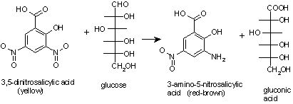
Fig 11.1: Formulas of few biomolecules
Procedure
- Deproteination: Take 2ml of sample in falcon tube, and then add 6ml of distilled water and 2ml of ethanol in it
- Place the tube in centrifugation machine at 4000rpm for 20 minutes and take supernatant, discard pellet.
- Take three test tubes label them as sample, standard and blankly.
- In sample tube add 1ml sample and 1ml DNS, Incubate at water bath for 7-10 minutes then add 4ml of distilled water.
- Similarly prepare standard and blank by adding 1ml standard and 1ml distilled water respectively followed by adding 1ml DNS, , Incubate at water bath for 7-10 minutes then add 4ml of distilled water.
- Now set spectrophotometer at 540nm, Set absorbance 0 for blank and measure absorbance of standard and sample.
Standard solution=10mg/100ml
CALCULATIONS;
Absorbance of standard= x
Absorbance of sample= y
X absorbance is due to 0.1mg glucose
Y absorbance is due to= 0.1/x×y=zmg
So 1ml contain glucose=zmg
100ml contain=z×100=Amg%

Practical No: 12 Determination of Proteins by UV/Visible Spectrophotometer

Theory
Estimation of protein concentration in a given protein preparation is one of the most commonly performed tasks in a biochemistry lab. There are several ways of estimating the protein concentration such as amino acid analysis following acid hydrolysis of the protein; analyzing the changes in the spectral properties of certain dyes in the presence of proteins; and spectrophotometric estimation of the proteins in near or far UV region. Although dye-binding assays and amino acid analysis following acid hydrolysis of the protein can be used for estimating the protein concentration for both pure as well as an unknown mixture of proteins; UV spectroscopic quantitation holds good for the pure proteins. If a protein is pure, UV spectroscopic quantitation is the method of choice because it is easy and less time-consuming to perform; furthermore, the protein sample can be recovered back.
Absorption of ultraviolet radiation is a general method used for estimating a large number of bioanalytes. The region of the electromagnetic radiation ranging from ~10 – 400 nm is identified as the ultraviolet region. For the sake of convenience in referring to the different energies of UV region, it can be divided into three regions:
- Near UV region (UV region nearest to the visible region; λ ~ 250 – 400 nm)
- Far UV region (UV region farther to the visible region; λ ~ 190 – 250 nm)
- Vacuum UV region (λ < 190 nm)
Materials:
- A UV/Visible spectrophotometer
- Pipettes
- Pipette tips
- Disposable microfuge tubes
- Quartz cuvettes (suitable for wavelengths smaller than 205 nm)
- Pure protein solution in a buffer (or in water)
- The buffer the protein is dissolved in (will act as the blank).
Procedure:
- Switch ‘ON’ the UV/visible spectrophotometer and allow it 30 minutes warm up.

- Determine the molar absorption coefficient of the protein at 280 nm using equation:
𝜀280 = (5500 × 𝑛_{𝑇𝑟𝑝}) + (1490 × 𝑛_{𝑇𝑦𝑟}) + (125 × 𝑛_{𝑆−𝑆})
- Take the buffer used for protein dissolution in the quartz cuvettes.
The volume of buffer has to be sufficient enough to cover the entire aperture the light beam passes through and depends on the capacity of the quartz cuvette; typically cuvettes with 1 ml capacity are used.
- Place the cuvettes in the reference cell and sample cell slots in the spectrophotometer.
- ‘ZERO’ the baseline for the 250 – 350 nm range.
- Remove the quartz cuvette placed in the sample cell slot and discard all the contents..
- Add the same volume of the given protein solution into the cuvette and place it back in the sample cell slot.
- Record the absorbance at 280 nm ($A_{280}^{sample}$) and 330 nm ($A_{330}^{sample}$). a. Proteins do not absorb at wavelengths higher than 320 nm; any absorbance obtained at 330 nm therefore arises due to scattering. b. If the absorbance at 280 nm does not lie between 0.05 – 1.0, dilute the protein solution in the same buffer so as to obtain an absorbance in this range.
- Switch off the spectrophotometer.
- Take out the quartz cell and clean them using detergent solution and deionized water.
Calculation:
The absorbance at 280 nm is corrected for light scattering:
($A_{280 (Corrected)}^{sample}$) = $A_{280}^{sample}$ - 1.929 x ($A_{330}^{sample}$)
The amount of the given protein is determined using Beer-Lambert law (A = εcl)
($A_{280 (Corrected)}^{sample}$) = ɛcl
Notes:
- If the given protein lacks Trp, Tyr, and disulfide linkages, the concentration can be estimated using A205 or A215 and A225.
- If the protein solution is turbid, it will scatter light leading to inflated absorbance values. The solution should therefore be cleared either by filtering it through a 0.2 μm filter or through centrifugation.

Practical No: 13 Analysis of electrolytes by UV/Visible spectrophotometer

Analysis of Potassium Permanganate
Outcomes
After completing this experiment, the student should be able to:
- Determine wavelength of maximum absorption
- Use Beer’s Law to determine molar absorptivity.
- Explain the fundamental principal behind spectrophotometric analysis
Spectrophotometry Principle:
Spectrophotometry is a technique that uses the absorbance of light by an analyte (the substance to be analyzed) at a certain wavelength to determine the analyte concentration. UV/VIS (ultra violet/visible) spectrophotometry uses light in UV and visible part of the electromagnetic spectrum. Light of this wavelength is able to effect the excitation of electrons in the atomic or molecular ground state to higher energy levels, giving rise to an absorbance at wavelengths specific to each molecule. The complex formed between ASA and Fe3+ is intensely violet coloured, and therefore can be determined by spectrophotometry using the visible part of the electromagnetic spectrum.
Materials and Equipment
UV/VIS spectrophotometer and polystyrene cuvettes, 2 100 mL volumetric flask, 1000 μL micropipette, 100 μL pipet, Hot plate, solid KMnO4, 1 10 mL graduated cylinders, 6 10 mL volumetric flasks, 2 125 mL Erlenmeyer flasks or 150 mL beakers
Procedure
Preparing the stock solution and four standard solutions
1. Preparation of 100 mL of a stock standard solution of 0.008M KMnO4: Accurately weigh 126 mg solid KMnO4. Transfer quantitatively to a 100 mL volumetric flask and fill to the mark with water. This is the stock solution.
2. Prepare four standards in 10.o mL volumetric flask with concentrations of 0.00008 M (solution #1), 0.00016 M (solution #2), 0.0004 M (solution #3) and 0.0008 M (solution #4) by diluting the stock solution prepared in Step 1 as following.
For the 0.00008, 0.00016 and 0.0004 M standards use the 100 μL micropipets (100 μL = 0.1 mL; calculate how many 100 μL samples stock solution are needed in each case) to make 10 mL standard solution.For the 0.0008 M standard use the 1 mL (1000 μL) micropipet, Mark the four 10 mL flasks with standard solutions #1-4 (lowest concentration #1 = 0.00008 M, highest concentration #4 = 0.0008 M).
Measuring the absorption spectrum and determining λmax
This part of the experiment may be done by all students together, with each pair of students determining the absorbance at one wavelength. Each pair of students should record all absorbances at each wavelength and draw the absorption spectrum.
3. Rinse one of the cuvettes with distilled water and fill it with water. Put the cuvette in the sample compartment. This is the reference solution. Set the wavelength to 400 nm, then set the Absorbance to zero.
4. Rinse a second cuvette once with distilled water and once with standard solution #1, then fill it with standard solution #1 (0.0008 M KMnO4). Place the cell in the sample compartment, measure the Absorbance at 400 nm and record in your notebook.
5. Repeat this procedure (steps 3 and 4 above) for the two cuvettes at wavelengths 420, 440, 460, 600 nm, first setting A = 0 for the cuvette with water, then measuring A for the cuvette with 0.0008 M KMnO4, recording the absorbance at each wavelength. Prepare a graph of absorbance A vs. wavelength λ and determine λmax (maximum wavelength). Attach this graph to the lab report.
The calibration curve
This part of the experiment must be done by each pair of students separately.
7. Set the wavelength at 525 nm (λmax). Place the cuvette with distilled water in the cell compartment and again set the Absorbance to zero.
8. Measure and record the Absorbance of each of the four standard solutions, starting with the most dilute standard. After each measurement, rinse the cuvette with the next standard, not with distilled water!
9. Draw a plot having X-axis as concentration (mole/L) and Y-axis as Absorbance at λmax (525 nm). 10. Use Beer’s law to calculate ε for KMnO4, given the cell width (path length l) to be 1 cm.

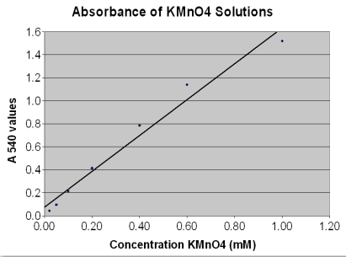
Fig 13.1: Absorbance and concentration of KMnO4

Practical No: 14 Determination of Sodium Content by Flame Photometer

Theory
Sodium (Na) is the major extracellular cation and it plays a role in body fluid distribution. Concentration of sodium ions inside the plasma (extracellular) is 130-145 mmol/l. Higher and lower concentrations are referred to as hypernatremia and hyponatremia, respectively.
The major cation of the extracellular fluid is sodium. The typical daily diet contains 130-280 mmol (8-15 g) sodium chloride. The body requirement is for 1-2 mmol per day, so the excess is excreted by the kidneys in the urine.
Hyponatraemia (lowered plasma [Na+]) and hypernatraemia (raised plasma [Na+]) are associated with a variety of diseases and illnesses and the accurate measurement of [Na+ ] in body fluids is an important diagnostic aid.
When a solution containing cations of sodium is spayed into flame, the solvent evaporates and ions are converted into atomic state. In the heat of the flame (temperature about 1800ºC), small fraction of the atoms is excited. Relaxation of the excited atoms to the lower energy level is accompanied by emission of light (photons) with characteristic wavelength (Na: 589 nm, K: 766 nm). Intensity of the emitted light depends on the concentration of particular atoms in flame.
Instruments, reagents and glassware
- Flame photometer FLAPHO or Eppendorf.
- oral rehydration sachet NaCl standards: 0.25, 0.5, 1.0, 2.0, 4.0 and 5.0 mM
- 6 numbered 100 ml volumetric flasks.
- Glass pipettes: 1, 2, 10 ml.
Analytical procedure
- Carefully open an oral rehydration sachet and empty the contents into a clean 250 ml beaker. Add about 150 ml distilled water and gently swirl the contents until dissolved.
- Pour the solution into a 200 ml volumetric flask and rinse out the beaker with small amounts of distilled water, adding the washings to the flask. Finally, make up the flask to exactly 200 ml and mix thoroughly.
- Make a 1/50 dilution of the re dissolved sachet solution by accurately pipetting 2 ml of the solution into a 100 ml volumetric flask and making up to 100 ml with distilled water.
Instructions for use of the flame photometer:
- Ensure that the photometer drain is leading into a sink and that the instrument is connected to gas, air and electricity supplies. Ensure the mains supply gas tap is off.
- Turn the "Sensitivity" and instrument "Gas" controls control fully counterclockwise (towards you).
- Insert the sodium optical filter.
- Switch on the instrument and unclamp the galvanometer by turning counterclockwise.
- Open the mica window, turn on the mains gas supply, light the gas and close the window.
- Turn on the air supply control and adjust the air pressure to 10 lb/in2. Leave for 1-2 minutes to stabilize.
- Place a beaker of distilled water into position at the left hand side of the instrument and insert the narrow draw tube into it to allow water to pass through the photometer. (NOTE: once set up, the photometer must have water running through it at all times when a salt solution is not being measured. The rate of uptake is fast, so make sure there is always enough water in the beaker).
- Adjust the gas control to give a flame with a large central blue cone then, with water passing through the instrument, slowly close the gas control until ten separate blue cones just form.
- Set the galvanometer to zero using the "Set zero" control.
- Replace the distilled water with the 5 mM NaCl standard and adjust the "Sensitivity" control till the galvanometer reads 100.
- Quickly but carefully, replace the 5 mM NaCl standard with standards of decreasing concentration from 4 mM to 0.25 mM and note the readings in the Table below.
- Run water through the instrument again for 1-2 min then place the draw tube into a beaker containing the 1 in 50 diluted rehydration sachet solution and note the galvanometer reading.
- Run water through the instrument again and replace the sodium with the potassium filter.
- Finally, run water through the instrument until the flame appears free of colour again.
- When the instrument is no longer required, switch off in the following sequence:
  - Turn off the gas control and the mains gas supply
  - Wait for the flame to die out.
  - Turn off the air supply.
  - Switch off the electricity
  - Clamp the galvanometer.
Table 14.1: Reading on flame photometer
[Na+ ] (mM) | 5.0 | 4.0 | 2.0 | 1.0 | 0.5 | 0.25 | 0
Galvo reading | 100 |  |  |  |  |  | 0
- Plot the galvanometer readings against Na+ concentration on the graph paper provided (separate graph for each ion) and from these calibration curves determine the Na+ concentration in the diluted sachet solution. Finally, calculate the Na+ concentrations in the undiluted sachet solution.

Practical No: 15 Determination of Potassium Content by Flame Photometer

Theory
Potassium (K) is the major cation found inside of cells. The proper level of potassium is essential for normal cell function. An abnormal increase of potassium (hyperkalemia) or decrease of potassium (hypokalemia) can profoundly affect the nervous system and heart, and when extreme, can be fatal. The normal blood potassium level is 3.5 - 5.0 millimoles/liter (mmol/l).
Potassium is the major cation found intracellularly. The average cell has 140 mM K+ inside but only about 10 mM Na+. K+ slowly diffuses out of cells so a membrane pump (the Na+ /K+ - ATPase) continually transports K+ into cells against a concentration gradient. The human body requires about 50-150 mmol/day.
Hypokalaemia (lowered plasma [K+), hyperkalaemia (increased plasma [K+ ]) and hyperkaluria (increased urinary excretion of K+ are again indicative of a variety of conditions and the clinical measurement of [K+ ] is also of great importance.
When a solution containing cations of Potassium is spayed into flame, the solvent evaporates and ions are converted into atomic state. In the heat of the flame (temperature about 1800ºC), small fraction of the atoms is excited. Relaxation of the excited atoms to the lower energy level is accompanied by emission of light (photons) with characteristic wavelength (K: 766 nm). Intensity of the emitted light depends on the concentration of particular atoms in flame.
Instruments, reagents and glassware
- Flame photometer FLAPHO or Eppendorf.
- oral rehydration sachet KCl standards: 0.25, 0.5, 1.0, 2.0, 4.0 and 5.0 mM
- 6 numbered 100 ml volumetric flasks.
- Glass pipettes: 1, 2, 10 ml.
Analytical procedure
- Carefully open an oral rehydration sachet and empty the contents into a clean 250 ml beaker. Add about 150 ml distilled water and gently swirl the contents until dissolved.
- Pour the solution into a 200 ml volumetric flask and rinse out the beaker with small amounts of distilled water, adding the washings to the flask. Finally, make up the flask to exactly 200 ml and mix thoroughly.
- Make a 1/50 dilution of the re dissolved sachet solution by accurately pipetting 2 ml of the solution into a 100 ml volumetric flask and making up to 100 ml with distilled water.
Instructions for use of the flame photometer:
- Ensure that the photometer drain is leading into a sink and that the instrument is connected to gas, air and electricity supplies. Ensure the mains supply gas tap is off.
- Turn the "Sensitivity" and instrument "Gas" controls control fully counterclockwise (towards you).
- Insert the sodium optical filter.
- Switch on the instrument and unclamp the galvanometer by turning counterclockwise.
- Open the mica window, turn on the mains gas supply, light the gas and close the window.
- Turn on the air supply control and adjust the air pressure to 10 lb/in2. Leave for 1-2 minutes to stabilize.
- Place a beaker of distilled water into position at the left hand side of the instrument and insert the narrow draw tube into it to allow water to pass through the photometer. (NOTE: once set up, the photometer must have water running through it at all times when a salt solution is not being measured. The rate of uptake is fast, so make sure there is always enough water in the beaker).
- Adjust the gas control to give a flame with a large central blue cone then, with water passing through the instrument, slowly close the gas control until ten separate blue cones just form.
- Set the galvanometer to zero using the "Set zero" control.
- Replace the distilled water with the 5 mM KCl standard and adjust the "Sensitivity" control till the galvanometer reads 100.
- Quickly but carefully, replace the 5 mM KCl standard with standards of decreasing concentration from 4 mM to 0.25 mM and note the readings in the Table below.
- Run water through the instrument again for 1-2 min then place the draw tube into a beaker containing the 1 in 50 diluted rehydration sachet solution and note the galvanometer reading.
- Run water through the instrument again and replace the sodium with the potassium filter.
- Finally, run water through the instrument until the flame appears free of colour again.
- When the instrument is no longer required, switch off in the following sequence:
  - Turn off the gas control and the mains gas supply
  - Wait for the flame to die out.
  - Turn off the air supply.
  - Switch off the electricity
  - Clamp the galvanometer.

Table 15.1: Reading on flame photometer
[K+ ] (mM) | 2.0 | 1.5 | 1.0 | 0.5 | 0.2 | 0.1 | 0
Galvo reading. | 100 |  |  |  |  |  | 0

- Plot the galvanometer readings against K+ concentration on the graph paper provided (separate graph for each ion) and from these calibration curves determine the K+ concentration in the diluted sachet solution. Finally, calculate the K+ concentrations in the undiluted sachet solution.
Table 15.2: Values to be put on flame photometer
 | Galvanometer reading | Diluted concentration (mM) | Undiluted concentration (mM)
Potassium ion

Practical No: 16 Mineral Analysis of Plant Tissues Using Atomic Absorption Spectrophotometer

Introduction
The analysis of plant tissue, generally leaves, is considered to be an important step in diagnosing and confirming a mineral element deficiency. The mineral element status of the plant can be accurately measured by the analysis of plant tissue if the tissue is properly sampled. Tissue analysis is often the best indication for recommending fertilizer or supporting nutrient spray treatments. The development of a relatively fast and accurate method of analyzing plant tissue has been made possible with the advent of atomic absorption spectroscopic techniques.
PRINCIPLE OF ATOMIC ABSORPTION SPECTROSCOPY
The atomic absorption technique utilizes the reverse of the flame emission technique. The element of interest is merely disassociated from its chemical bonds and reduced to the unionized "ground" state. The ground state atom is then capable of absorbing its own particular wavelength of radiation. The radiation is supplied by a hollow cathode lamp which emits only the wavelength of the material from which it is constructed along with the wavelength of the filler gas. For example, in Zn analysis, a Zn hollow cathode lamp is used, allowing only the "ground" state Zn atoms to absorb the radiation. The other elements in the solution are not "seen" by the instrument since only the Zn wavelength radiation is supplied by the lamp. The only requirement for AAS is that the element be in solution.
Sample preparation
The different parts of plants including leaves, aerial roots, fruits and bark were rinsed with tap water and then with distilled water in order to remove surface contamination and dried at 55 to 60°C in an electric oven. The dried plant samples were then homogenized in pistil mortar.
Digestion and analysis of sample
- 0.25 g each of the powdered plant samples is digested in 6.5 ml of acid solution (HNO3, H2SO4, HClO4 in ratio of 5:1:0.5).
- Heat he corresponding solution until white fumes appeared.
- Dilute the clear solution upto 50 ml with distilled water and filter with Watt man filter paper no.1.
- Prepare the standard working solutions of elements to make the standard calibration curve.
- Absorption for a sample solution uses the calibration curves to determine the concentration of particular element in that sample.
- Use Varian AA240FS atomic absorption spectrometer (AAS) for the determination of thirteen metals that is, Na, K, Ca, Mg, Mn, Zn, Ni, Co, Fe, Cu, Cr Cd and Pb.
- Cathode lamps would be used as radiation source.
- Air acetylene gas would be used for all the experiments.
- This method provides both sensitivity and selectivity since other elements in the sample will not generally absorb the chosen wavelength and thus, will not interfere with the measurement
Table 16.1: Following instrumental parameters would be followed
Element | Slit width | Instrument setting | Actual wavelength ºA | Acetylene air settings | Detection limits, ppm | Standard concentration range  ppm
Zn | 7 ºA | 83.5 | 2138 | 13.35 - 12.4 | 0.06 | 0 – 2
Fe | 2 ºA | 144.8 | 2483 | 13.35 - 12.4 | 0.09 | 0-1 0
Mn | 7 ºA | 199.5 | 2798 | 13.35 - 12.4 | 0.18 | 0 – 8
Ca | 7 ºA | 459 | 4227 | 13.35 - 12.4 | 0.18 | 0 – 8
K | 7 ºA | 425.9 | 4044 | 13.35 - 12.4 | 28.6 | 0 – 500
Mg | 7 ºA | 209.5 | 2852 | 13.35 - 12.4 | 0.02 | 0 - 0.5

- The wavelength parameter must be peaked for each element each time the element is determined since it is imperative to operate the instrument on the correct peak of the wavelength.
- This is particularly important when there is more than one wavelength peak for an element. The acetylene - air settings are only preliminary since each burner must be adjusted to yield the maximum absorption for a particular element.

References
- Burtis, Carl A et al. Tietz Fundamentals of Clinical Chemistry, 6th ed. Saunders: St Louis, Missouri, 2008.
- Naser, Najih. Clinical Chemistry Laboratory Manual. Mosby: St Louis, Missouri, 1998.
- Pointe Scientific, Inc package insert. February 2009.
- Pavia, D.L., Lampman, G.M., Kriz, G.S., and Engel, R.G. Introduction to Organic Laboratory Techniques: A Microscale Approach 3rd Edition Saunders College Publishing: New York, NY, 1999.
- Scopes, R. K. (1974) Measurement of protein by spectrometry at 205 nm. Analytical Biochemistry, 59, 277–282.
- Waddell, W. J. (1956) A simple UV spectrophotometric method for the determination of protein. The Journal of Laboratory and Clinical Medicine,48, 311–314.
- https://www.liverpool.ac.uk/~agmclen/Medpracs/practical_2/practical_2.pdf
- http://web.pdx.edu/~atkinsdb/teach/427/Expt-AtomicSpec.pdf
- The analysis of pecan leaves by atomic absorption spectroscopy. Morris W. Smith & J. Benton Store
- https://msu.edu/course/lbs/159h/Chromatography04.pdf
- http://www.biologyreference.com/Re-Se/Separation-and-Purification-of-Biomolecules.html#ixzz4eaKK26gx

